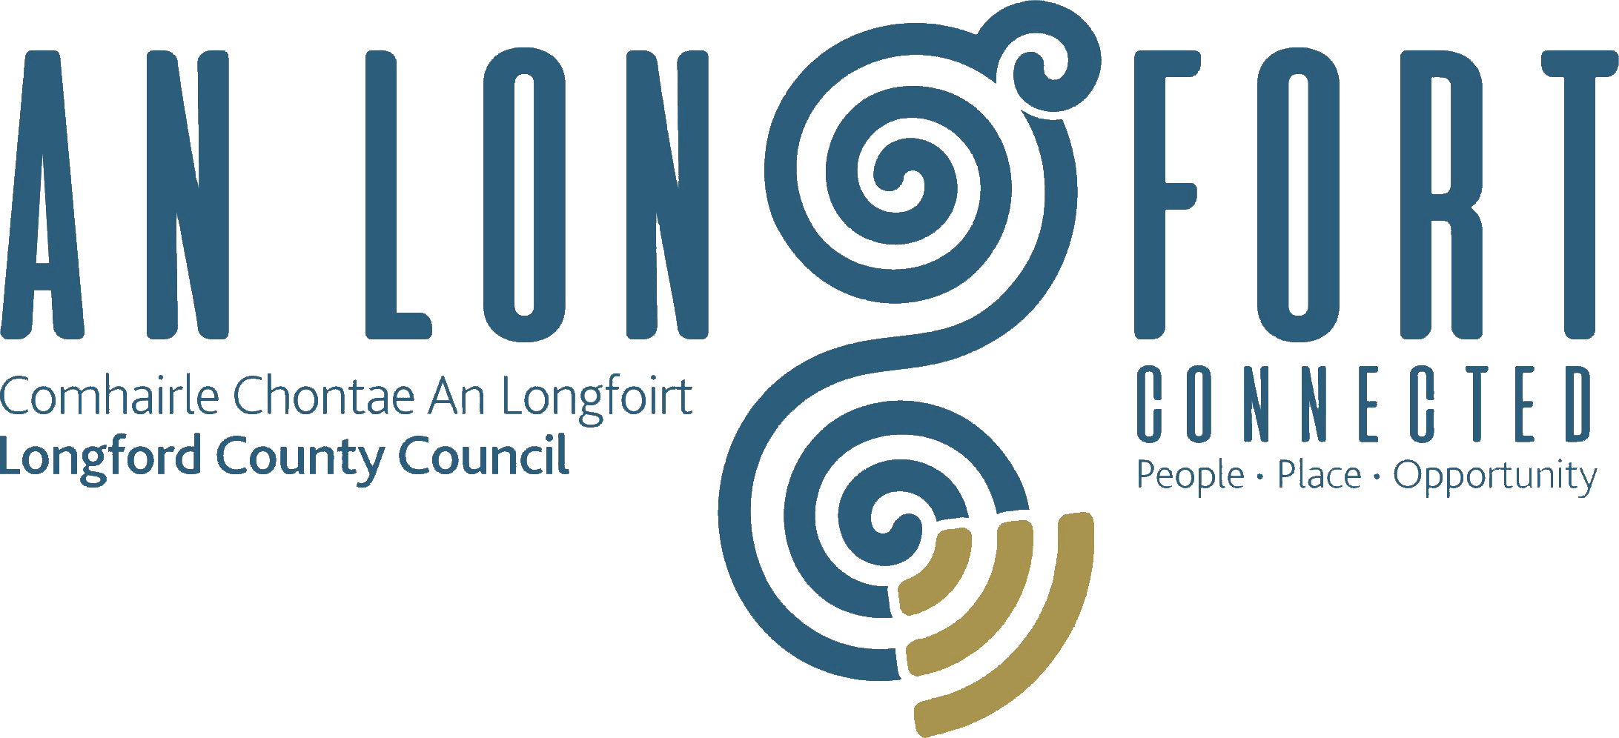

Minutes of Monthly Meeting of Longford County Council
held in the Council Chamber, Aras an Chontae, Great Water Street, Longford on
Wednesday, 9th May 2018 at 3.30 p.m.
____________________________________________________________________

PRESIDING: Councillor Martin Mulleady, Cathaoirleach.

MEMBERS PRESENT: Councillors – Paraic Brady, John Browne, Seamus Butler, Micheál Carrigy, Mark Casey, Joe Flaherty, Gerard Hagan, Luie McEntire, Colm Murray, Peggy Nolan, Pat O’Toole,
P.J. Reilly, Paul Ross, Mae Sexton and Gerry Warnock.

APOLOGIES: Councillors Mick Cahill and Gerard Farrell.

IN ATTENDANCE: Mr. Paddy Mahon, Chief Executive.
Mr. John McKeon, Head of Finance.
Ms. Barbara Heslin, Director of Services.
Mr. John Brannigan, Director of Services.

MEETINGS
ADMINISTRATOR: Ms. Anne Lee.

PRESENTATION BY OLDER PERSONS COUNCIL.

Kitty Hughes, Chairperson of County Longford Older Persons Council and Des Skelly,
Vice –Chairperson gave a comprehensive presentation regarding the Older Persons Council, and highlighted the following -

- County Longford Age Friendly Strategy.
- Longford Older Persons Council.
- Plain English Guide to Social Housing Support application forms.
- Local Service Information Leaflet.
- Community Fire Alarm Scheme.
- Walkability Survey.
- Integrated Care Programme for Older People.
- Crime Prevention Ambassadors Programme - Sergeant Lionel Mullally gave a
presentation regarding the CPA programme in County Longford.
- Bealtaine Festival
Kitty complimented Paddy Mahon, Mary Carleton-Reynolds, the staff of Longford County Council, Catherine McGuigan, National Co-Ordinator, Superintendent Jim Delaney and Sergeant Lionel Mullally, Councillor Gerry Warnock, Chairperson of the Joint Policing Committee for all their assistance in what has been achieved to date. Kitty stated that she has full confidence that the goal of making County Longford a better place in which to grow old will continue through this partnership approach.

Superintendent Delaney and Chief Executive, Paddy Mahon, complimented the Older Persons Council on their excellent work to date and assured them of their continued support.

LAUNCH OF “WHAT’S ON GUIDE TO COUNTY LONGFORD.”

The Cathaoirleach launched the “What’s On Guide to County Longford” and complimented Mary Carleton Reynolds and the members of the Culture Team who were involved in the production of the Guide.

JOBS ANNOUNCEMENTS – FINESSE MEDICAL.

The Cathaoirleach welcomed the recent announcement regarding the expansion of Finesse Medical and the creation of 200 additional jobs.

MEETING WITH REPRESENTATIVES FROM THE HSE.

The Meetings Administrator informed the members that representatives from the HSE have agreed to meet with representatives from the Council regarding health issues.

The HSE have requested that the proposed meeting be held in committee and that the items to be discussed be forwarded to the HSE in advance of the meeting so that the relevant HSE personnel attend the meeting.

Councillor P. Nolan proposed and Councillor M. Sexton seconded the following –

- The proposed meeting be held in public.
- Queries not to be sent in advance of the meeting.

ADOPTION OF MINUTES.

On the proposal of Councillor P. Brady seconded by Councillor P. Nolan, the Minutes of Monthly Meeting of Longford County Council held on the 11th April 2018, as circulated, were confirmed and adopted.

MATTERS ARISING FROM MINUTES.

None.

CHIEF EXECUTIVE ORDERS.

The Chief Executive Orders, as circulated, were noted.

MONTHLY MANAGEMENT REPORT.

The Monthly Management Report, as circulated, was noted.

Incremental Purchase Scheme.

Councillor M. Sexton proposed and Councillor G. Warnock that a letter be forwarded to the Department of Housing, Planning & Local Government asking when the review of the Incremental Purchase Scheme will be complete.

CORPORATE POLICY GROUP MINUTES.

The adopted Minutes of Corporate Policy Group Meeting held on the
14th March 2018, as circulated, were noted.

FINANCE & INFORMATION SYSTEMS.

Public Liability Claims.

It was noted that two Public Liability Claims were received during April 2018.

Annual Financial Statement for Year ended 31st December 2017 – circulated.

The 2017 Draft Annual Financial Statement was circulated with the Agenda for the meeting.

J. McKeon, gave a comprehensive presentation on the Draft Annual Financial Statement 2017, and replied to queries raised by the members.

Councillor M. Sexton proposed and Councillor M. Mulleady seconded that a letter be forwarded to the Minister for Finance requesting that the Local Property Tax bands be reviewed.

On the proposal of Councillor S. Butler seconded by Councillor M. Sexton, it was unanimously agreed to adopt the Annual Financial Statement 2017 as circulated, subject to audit by the Local Government Auditor.

The Cathaoirleach and members complimented John and the staff in Finance for their excellent work.

Approval to Additional Expenditure under S104(7) of the Local Government Act 2001.

On the proposal of Councillor M. Sexton seconded by Councillor P. Brady, it was unanimously agreed to approve of Additional Expenditure under S104(7) of the Local Government Act 2001, as outlined by the Head of Finance.

Transfers from Reserves.

On the proposal of Councillor P. Nolan seconded by Councillor P. Brady, it was unanimously agreed to the transfer from Reserves under S104(7) of the Local Government Act 2001, as outlined by the Head of Finance.

Loan from the Housing Finance Agency.

On the proposal of Councillor Seamus Butler seconded by Councillor Pat O’Toole, it was unanimously agreed to approve of Loan of €1,200,000 from the HFA to finance approved
Housing Loan applications, as authorised by the Housing Acts 1966-1992.

ECONOMIC AND COMMUNITY DEVELOPMENT, PLANNING, HUMAN RESOURCES & CORPORATE SERVICES, CULTURAL & RECREATIONAL SERVICES.

Planning Applications.

The list of Planning Applications received since April meeting of the Council was noted.

TOWN AND VILLAGE RENEWAL SCHEME.

Barbara briefed the members on the Town and Village Renewal Scheme.
Applications from towns and villages can range from €20,000 to a maximum of €100,000. Funding of up to €200,000 will also be considered for a limited number of projects which can deliver exceptionally strong economic benefits to a town and its outlying areas. Selection of projects under the Scheme will be by means of a competitive process. Final project selection will be made by the Department of Rural and Community Development on the basis of applications submitted by the Local Authorities.
The Council is seeking Expressions of Interest from town/village groups who may have a suitable project for consideration under the Scheme. All Expressions of Interest will be assessed based on the priorities as contained in the Scheme Outline. It is proposed to hold Information Sessions on the Scheme. All interested town/village groups who wish to submit an Expression of Interest should return completed forms and details to the Regeneration Unit no later than 4pm on Friday, 25th May.
INTERCULTURAL STRATEGIC PLAN FOR COUNTY LONGFORD.

Barbara informed the members that Longford County Council has accepted a tender from Brehon Advisory, a not for profit company, to review and update the Intercultural Strategic Plan for County Longford. The new strategy will aim to meet locally identified needs and priorities of the Migrant, Traveller and Roma community in County Longford.

Dr. Shelley Deane, from Longford, will lead the development of the Plan. She has already commenced her work and has met with a Working Group from various public bodies and agencies in the county. She has also made arrangements to meet various groups around the county in the coming weeks. She will also be available for public consultation on Friday, 18th May in the Longford Library.
It is proposed to present a draft Intercultural Strategy for the consideration of members at the June 2018 meeting of the Council.

GENERAL.

Correspondence – circulated.

Nominations for President of Ireland.

- Correspondence received from Dr. John McHugh, USA, seeking support for his nomination as a candidate for President of Ireland.
- Correspondence received from Marie Goretti Moylan, “Dun na Marc”, 15 Auburn Villas, Athlone, Co. Westmeath seeking support for her nomination as a candidate for President of Ireland.
- Correspondence received from Kevin Sharkey seeking support for his nomination as a candidate for President of Ireland.

- noted by the members.

Correspondence received from the Office of the Minister for Children and Youth
Affairs regarding Early Years Services rates payments was noted.

Correspondence received from the Office of the Minister for Agriculture, Food and Marine regarding the fodder situation was noted. A further email to be forwarded to Minister Creed regarding the members concerns.

Correspondence received from Deputy Robert Troy regarding the sale of mortgage accounts by Irish lenders was noted.

This concluded the business of the meeting.
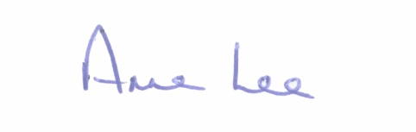

Signed: _______________
Anne Lee,
Meetings Administrator.

Confirmed and adopted at Monthly Meeting of Longford County Council held on the
13th June 2018.

Signed: _______________
Cathaoirleach.

